In-Depth Research Report on SSRF (Server-Side Request Forgery)



Introduction
Server-Side Request Forgery (SSRF) is a critical security vulnerability in web applications where an attacker is able to manipulate a server into making unintended requests on their behalf. The attacker exploits the server's ability to initiate HTTP requests to other resources within the network or the internet, often bypassing security controls and firewall restrictions that would normally block direct access. SSRF vulnerabilities can be used to access internal services, leak sensitive data, or trigger other forms of attacks.
This report aims to provide an in-depth understanding of SSRF, including what it is, the different types of SSRF vulnerabilities, their impact on web applications and systems, and effective mitigation measures.

What is SSRF?
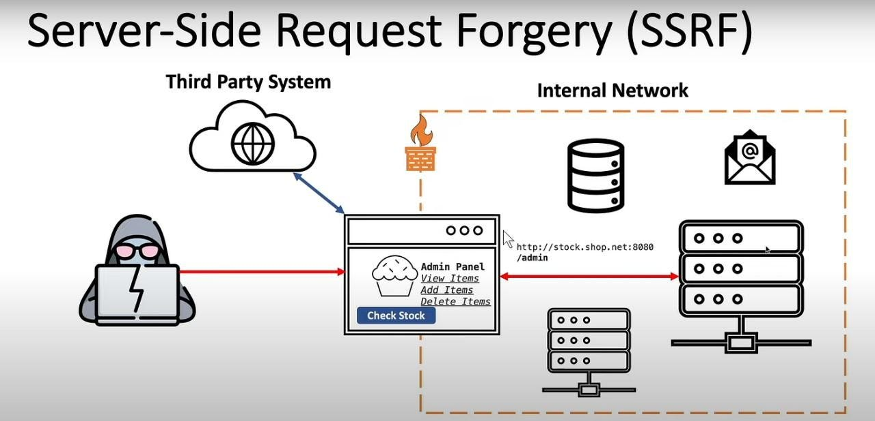
Server-Side Request Forgery (SSRF) is a type of vulnerability where an attacker is able to make the server (often an HTTP client) initiate arbitrary requests. These requests are made to internal or external resources that the attacker otherwise would not have access to. The server, typically an application that is trusted and has network privileges, becomes a proxy for the attacker's malicious request.
In a typical SSRF attack, the attacker manipulates user input that is passed to a server-side component which is responsible for fetching data from a URL. Instead of accessing a legitimate or allowed resource, the attacker can modify the URL to point to internal network resources, services, or other targets that are normally restricted.
For example, an attacker could exploit a vulnerable web application that fetches data from a URL provided by the user. If the application does not properly sanitize the URL input, an attacker might inject a request to access an internal server or service, like an admin panel or a cloud metadata API.

Types of SSRF
There are several types of SSRF attacks, depending on how the attacker manipulates the server to send the request. Below are the most common types:

1. Basic SSRF
In a basic SSRF attack, the attacker simply manipulates the URL input that is sent by the server. This type of attack often involves redirecting the server to internal resources or endpoints that it is not supposed to access.
Example:
An application allows users to submit URLs to fetch images or data. An attacker could submit a URL like http://localhost:8000/admin, which causes the server to access an internal resource.

SSRF Against Internal Services
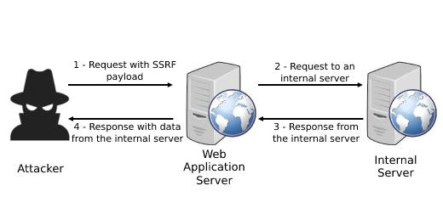
In this type of attack, the attacker exploits the server to make requests to internal services that are not directly exposed to the internet. This could include accessing services such as a cloud provider’s metadata API, internal databases, or private admin interfaces.
Example:
An attacker can exploit a web service that fetches data from an arbitrary URL and send requests to http://169.254.169.254/latest/meta-data/, which is a common endpoint for cloud metadata services. By doing so, the attacker could retrieve sensitive instance metadata (like access keys and secrets) from the cloud infrastructure.

3. Blind SSRF
Blind SSRF is a variant of SSRF where the attacker does not receive any immediate response from the target system. In these cases, attackers typically use techniques such as timing-based or error-based inference to determine the results of their SSRF attack.
Example:
An attacker may send an SSRF request that targets an internal service, and by measuring the response time or any other indirect information, they can infer whether the target service is vulnerable or exposed.

SSRF to Trigger Remote Code Execution (RCE)
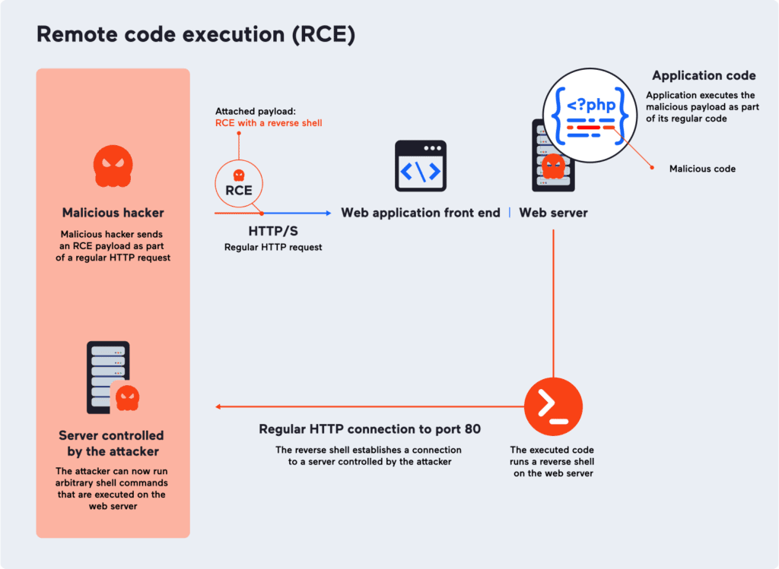
In some advanced cases, SSRF can be leveraged to trigger a remote code execution vulnerability. This happens when the SSRF allows the attacker to interact with services that are vulnerable to command injection or other forms of code execution.
Example:
An attacker may be able to use SSRF to reach an internal system that has a vulnerability allowing them to execute arbitrary code, such as a vulnerable SSH server or a misconfigured web server.

SSRF via DNS Resolution
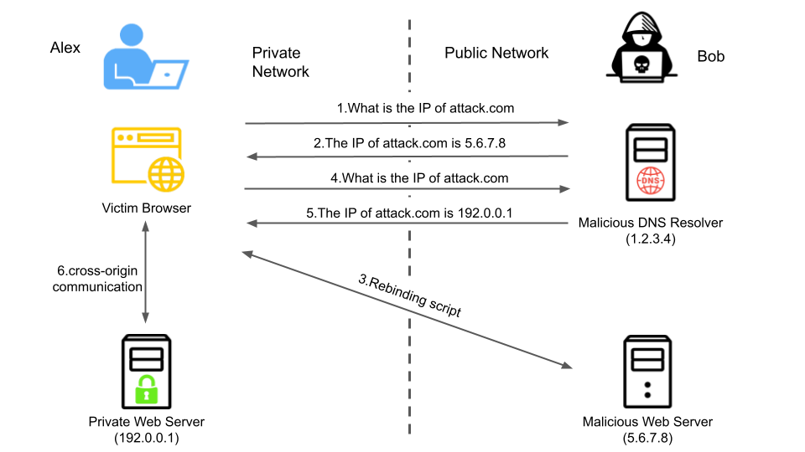
In this type of SSRF, the attacker crafts a malicious request that forces the server to resolve DNS names. This can lead to a DNS-based SSRF attack where the server is tricked into resolving internal or private DNS names that should not be accessible.
Example:
An attacker could manipulate an input field to force the server to resolve a private DNS record like internal.company.local, which could expose internal network structures or services.

6. SSRF via File Uploads or URL Handling
In this case, attackers manipulate file uploads or URL handling functions to make the server initiate requests to unauthorized resources. This is often combined with other vulnerabilities such as insecure deserialization or improper validation of uploaded files.
Example:
An attacker uploads a specially crafted file containing an internal URL that the server fetches, leading to unauthorized access of internal resources.

Impact of SSRF Vulnerabilities
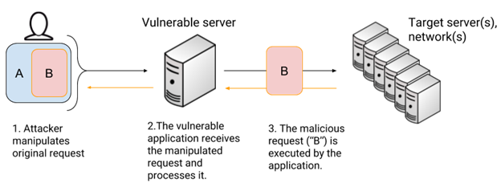
SSRF can have severe consequences for web applications and infrastructure. Some of the potential impacts include:

1. Unauthorized Access to Internal Systems
SSRF can be used to bypass firewalls or other network protections, allowing attackers to access services on internal networks that are not exposed to the public. This can include accessing sensitive systems, admin interfaces, or private APIs that were never meant to be publicly available.

2. Data Exfiltration and Information Leakage
Attackers can use SSRF to query internal resources that contain sensitive information. This could include metadata APIs (such as AWS or Azure instance metadata), which may leak instance-related data such as credentials, environment variables, and configuration details.

3. Remote Code Execution (RCE)
If an SSRF vulnerability allows access to a vulnerable service that is susceptible to code execution, attackers can escalate their attack from SSRF to Remote Code Execution (RCE), allowing them to compromise the server and potentially escalate to full system compromise.

4. Access to Cloud Metadata Services
In cloud environments, SSRF is particularly dangerous because attackers can use it to query metadata APIs (like AWS EC2 metadata or GCP metadata) to gain access to sensitive configuration information, including API keys and instance metadata, which could be used for further attacks.

5. Disruption of Internal Services
In some cases, SSRF can be used to send requests to internal services in a way that leads to resource exhaustion or denial-of-service (DoS) conditions, causing internal systems to become unresponsive or crash.

Mitigation Measures for SSRF
There are several strategies to mitigate SSRF vulnerabilities:

1. Input Validation and Whitelisting
The most effective way to mitigate SSRF is by validating and sanitizing user inputs:
- Input Filtering: Ensure that URLs and other user-supplied input are properly validated. For example, only allow certain trusted domains or protocols (like http://, https://) and restrict access to internal or private IP ranges.
- URL Whitelisting: Limit the domains or IP addresses that the server can communicate with by implementing a whitelist of allowed destinations.

2. Block Access to Internal Services
Restrict access to sensitive internal resources:
- Use firewall rules or network segmentation to prevent the application server from being able to make arbitrary requests to internal services or metadata APIs.
- Block access to private IP ranges and internal resources (like 127.0.0.1, localhost, and 169.254.169.254 in cloud environments).

3. Disable Unnecessary Features
If the application does not require the ability to fetch arbitrary URLs, consider disabling the functionality entirely. This minimizes the attack surface and eliminates the possibility of SSRF exploitation.

4. Use Secure Libraries and Methods
Use secure methods for making HTTP requests, and ensure that libraries or frameworks do not allow or expose dangerous functionality. Avoid using functions that allow direct access to internal resources or that don’t provide proper error handling and validation.

5. Implement Robust Logging and Monitoring
Implement logging and monitoring mechanisms that can detect unusual or suspicious requests to internal systems. Set up alerting for access attempts to unexpected or unauthorized resources (like localhost, internal APIs, or metadata services).

6. Apply Network and Service Layer Security
- Web Application Firewall (WAF): Use WAFs to filter malicious requests that attempt to exploit SSRF vulnerabilities.
- Network Segmentation: Ensure that the network is segmented such that internal systems and services are not directly accessible by the public-facing application.

7. Patch and Update Regularly
Ensure that all components (libraries, frameworks, and dependencies) are up-to-date with the latest security patches to prevent exploitation of known vulnerabilities.

Conclusion
Server-Side Request Forgery (SSRF) is a dangerous vulnerability that can allow attackers to access sensitive internal resources, exfiltrate data, and even compromise systems through various attack vectors. It is essential for organizations to be aware of the different types of SSRF, the potential impacts, and most importantly, the mitigation strategies. By following best practices in input validation, access control, and network security, organizations can significantly reduce the risk of SSRF exploitation.

References
- OWASP – Server Side Request Forgery (SSRF)
- PortSwigger – SSRF: A Web Security Exploit
- MITRE – SSRF (CWE-918)
- OWASP Cheat Sheet Series – SSRF Prevention Cheat Sheet

